PCA Analysis and Clustering of Ca Activity Data
I calculated maximum intensity projection image from one of my recordings, and select ROI’s by hand as a ground truth selection, then I created a mask using ImageJ.
Max intensity projection:
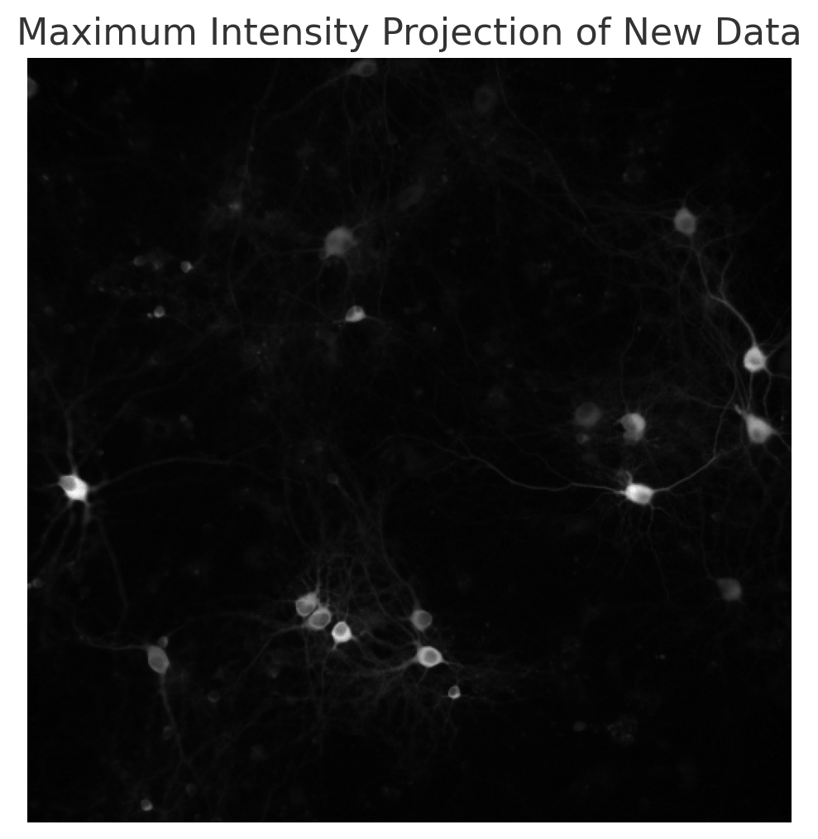
Masked image:
I want to write a python code that makes this steps automatically.

#loaded tiff video file
#normalized the images so their pixel values mostly fall between 0 and 1
#converted the images as float32 <- the data type that is fast for GPU computation
import numpy as np
import tifffile

# Define the normalization function
def normalize99(img):
X = img.copy()
x01 = np.percentile(X, 1)
x99 = np.percentile(X, 99)
X = (X - x01) / (x99 - x01)
return X.astype(np.float32)

# Load the TIF file
file_path = 'path_to_your_tif_file.tif'
tif = tifffile.TiffFile(file_path)

# Read the images into a list and apply normalization
normalized_frames = [normalize99(frame.asarray()) for frame in tif.series[0].pages]

# Compute the Maximum Intensity Projection (MIP)
mip = np.max(normalized_frames, axis=0)
mip image:


# Scikit-image provides a function named try_all_threshold that applies various thresholding methods to an image and displays the results side by side for easy comparison. I thought that this part can be asked to user.
from skimage.filters import try_all_threshold
import matplotlib.pyplot as plt
# normalize intensity across image
max_img_filtered = max_img.copy() / gaussian_filter(mip, 100)
# high pass filter
max_img_filtered = max_img_filtered - gaussian_filter(mip, 10)
max_img_filtered = normalize99(max_img_filtered)
fig, ax = try_all_threshold(mip, figsize=(10, 8), verbose=False)
plt.show()
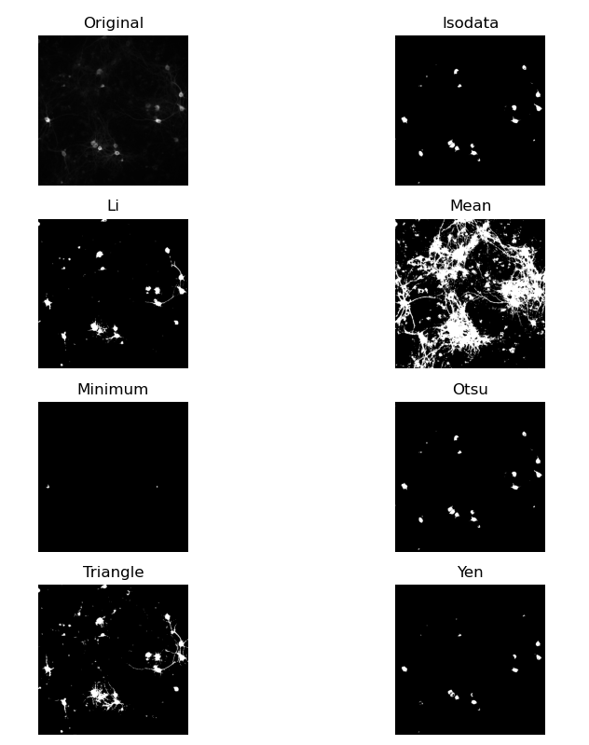
In this project I don’t need to get all the cells, but in long term I need to use deep learning algorithms for proper segmentation.
This is the results that I get using Cellpose, and it’s super impressive https://www.cellpose.org/:
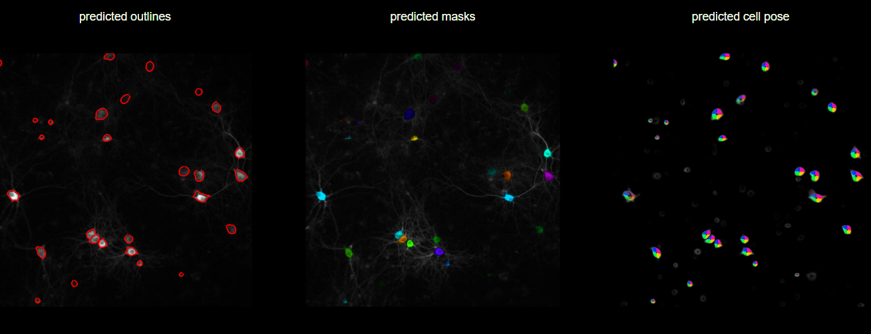

# Calculate the Otsu threshold
threshold_value = filters.threshold_otsu(mip)
# Generate the binary mask
binary_mask = mip > threshold_value
# Display results
fig, ax = plt.subplots(1, 2, figsize=(12, 5))

# Histogram and Otsu threshold
ax[0].hist(mip.ravel(), bins=256)
ax[0].axvline(threshold_value, color='r', linestyle='dashed', linewidth=2)
ax[0].set_title('Histogram of Normalized MIP')
ax[0].set_xlabel('Intensity Value')
ax[0].set_ylabel('Frequency')
# Binary mask
ax[1].imshow(binary_mask, cmap='gray')
ax[1].set_title('Binary Mask of Normalized MIP')
ax[1].axis('off')
plt.tight_layout()
plt.show()

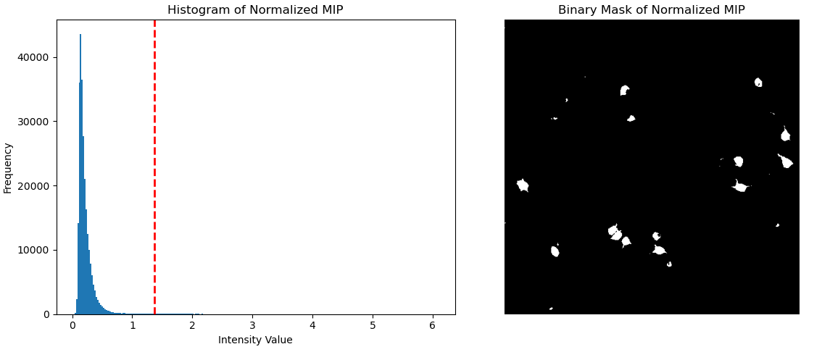
#Assigning a different colour for each cell
import numpy as np
import matplotlib.pyplot as plt
from skimage.measure import label
from skimage.color import label2rgb
import random
# Function to generate a unique color for each label
def generate_unique_colors(num_labels):
random.seed(42) # Seed for reproducibility
colors = [(0, 0, 0)] # Background color
for _ in range(1, num_labels + 1):
# Generate a unique color for each label, avoiding too dark colors
colors.append((random.random()*0.6 + 0.4, random.random()*0.6 + 0.4, random.random()*0.6 + 0.4))
return colors

# Label the connected regions in the binary mask
labeled_mask = label(binary_mask, connectivity=2)

# Generate unique colors
num_labels = labeled_mask.max()
unique_colors = generate_unique_colors(num_labels)

# Create an RGB image with the unique colors
colored_labeled_image = np.zeros((*labeled_mask.shape, 3), dtype=float)
for label, color in enumerate(unique_colors):
colored_labeled_image[labeled_mask == label] = color

# Display the colored labeled image
plt.figure(figsize=(6, 6))
plt.imshow(colored_labeled_image)
plt.title('Labeled Cells with Unique Colors')
plt.axis('off')
plt.show()
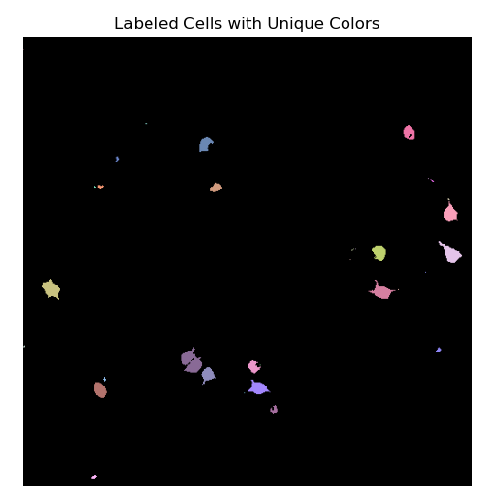
Here I have two problems: 1. Cells with very small radius, 2. Different cells identified as one single cell. I will correct this issue in the future.
cell_intensities = {label: [] for label in range(1, num_labels + 1)}

# Iterate over each frame to calculate average intensities
for frame in normalized_frames:
for label in cell_intensities.keys():
cell_mask = labeled_mask == label
cell_intensity = frame[cell_mask].mean()
cell_intensities[label].append(cell_intensity)

# Plotting
fig, axs = plt.subplots(2, 1, figsize=(12, 10))

# Display the labeled mask
colored_labeled_image = np.zeros((*labeled_mask.shape, 3), dtype=float)
for label, color in enumerate(unique_colors):
colored_labeled_image[labeled_mask == label] = color

axs[0].imshow(colored_labeled_image)
axs[0].set_title('Labeled Cells with Unique Colors')
axs[0].axis('off')

# Display the activity data
for label, intensities in cell_intensities.items():
axs[1].plot(intensities, color=unique_colors[label], label=f'Cell {label}')

axs[1].set_title('Average Intensity Over Time for Each Cell')
axs[1].set_xlabel('Time (Frame Number)')
axs[1].set_ylabel('Average Intensity')
axs[1].legend(bbox_to_anchor=(1.05, 1), loc='upper left', borderaxespad=0.)

plt.tight_layout()
plt.show()

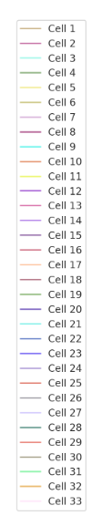
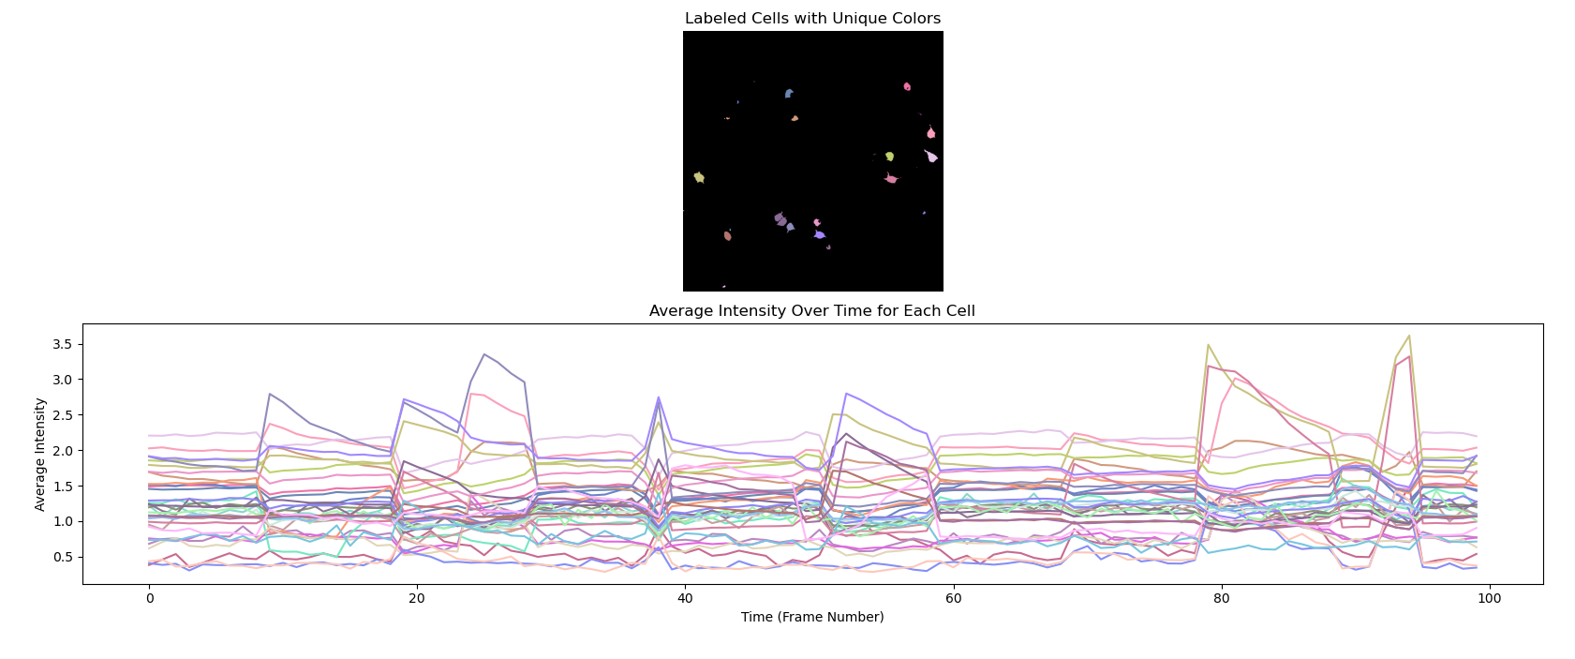
To find the correlation between cells, first I plotted the correlation matrix between cell activities:
# Convert the cell intensities dictionary to a list of lists for easier manipulation
intensity_values = list(cell_intensities.values())
# Convert the list of lists into a NumPy array for easier mathematical operations
intensity_array = np.array(intensity_values)
# Calculate the correlation matrix between the activities of the cells
correlation_matrix = np.corrcoef(intensity_array)
# Display the correlation matrix
plt.figure(figsize=(10, 8))
plt.imshow(correlation_matrix, cmap='viridis', interpolation='nearest')
plt.colorbar()
plt.title('Correlation Matrix between Cell Activities')
plt.xlabel('Cell Number')
plt.ylabel('Cell Number')
plt.show()
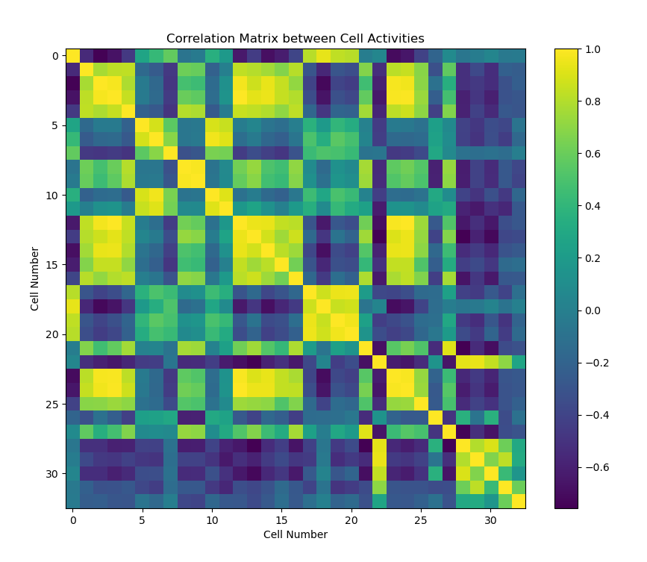
A value close to 1 indicates a strong positive correlation, close to -1 indicates a strong negative correlation. Values near 0 indicate little to no linear relationship between the activities of the cells. Then, I calculated the PCA and clustered them with Kmeans clustering method.
from sklearn.decomposition import PCA
from sklearn.cluster import KMeans
pca = PCA(n_components=2)
pca.fit(correlation_matrix)
components = pca.components_
explained_variance = pca.explained_variance_
# Plot the first two principal components
plt.figure(figsize=(12, 6))
for i, (component, variance) in enumerate(zip(components, explained_variance), start=1):
plt.subplot(1, 2, i)
plt.bar(range(len(component)), component)
plt.title(f'PC{i} - Variance: {variance:.2f}')
plt.xlabel('Cell Number')
plt.ylabel('Component Weight')
plt.tight_layout() # Correct placement
plt.show()
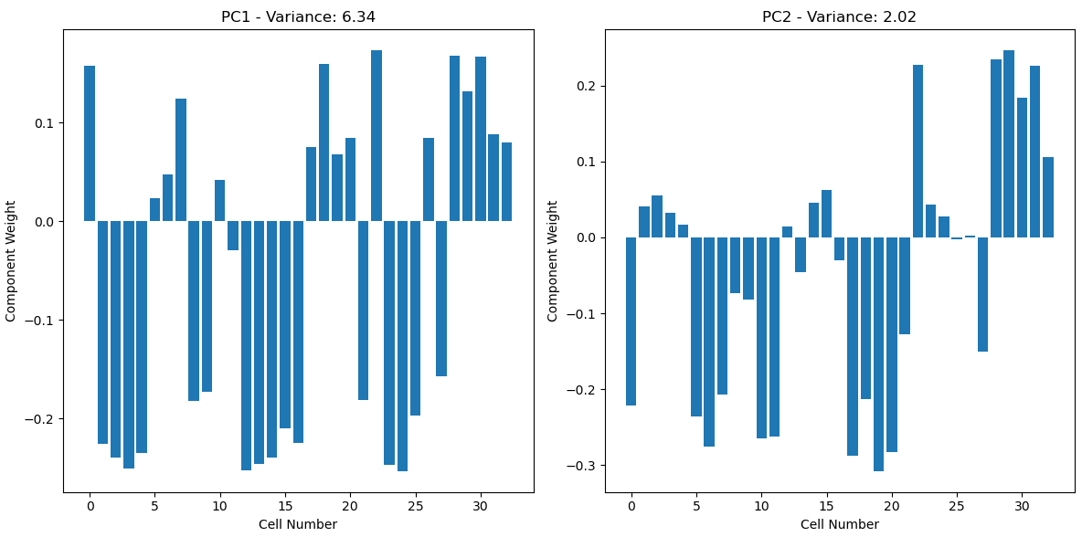
# Project the original correlation matrix data onto the first two principal components
pca_projection = pca.transform(correlation_matrix)
inertia = []
for n_clusters in range(1, 11):
kmeans = KMeans(n_clusters=n_clusters, random_state=42)
kmeans.fit(pca_projection)
inertia.append(kmeans.inertia_)
optimal_clusters = 3 # Adjust this value based on the Elbow method result
kmeans = KMeans(n_clusters=optimal_clusters, random_state=42)
cluster_labels = kmeans.fit_predict(pca_projection)

# Plot the clusters with cell numbers
plt.figure(figsize=(10, 8))
colors = plt.cm.viridis(np.linspace(0, 1, optimal_clusters))
for i, color in zip(range(optimal_clusters), colors):
plt.scatter(pca_projection[cluster_labels == i, 0], pca_projection[cluster_labels == i, 1],
color=color, marker='o', edgecolor='k', s=50, label=f'Cluster {i+1}')

# Label each point with its cell number
for i, (x, y) in enumerate(pca_projection):
plt.text(x, y, str(i + 1), color='black', fontsize=9)
plt.title('Clusters of Cell Activities (PCA Projection)')
plt.xlabel('PCA 1')
plt.ylabel('PCA 2')
plt.colorbar(label='Cluster Label')
plt.legend()
plt.tight_layout()
plt.show()

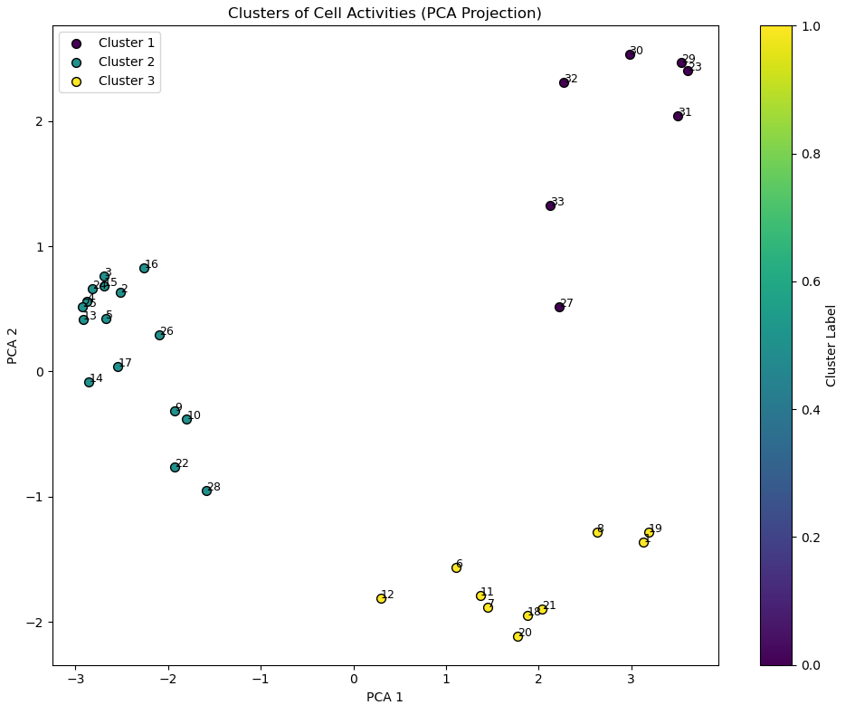
I will apply the same methods to my data after adding a specific drug and see the activity response of the cells. Thank you for reading and many thanks to chatgpt

